Staying Connected to My Teacher
I am not going to school right now because of the coronavirus. My teacher may call my home to talk to my parent(s) and me. My teacher is being kind by calling to see if my family and I are okay. My teacher may first talk to my parent(s).

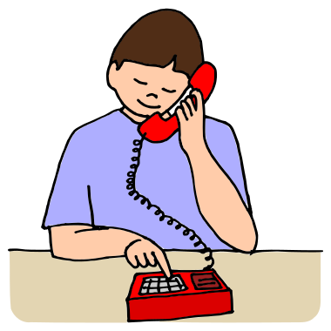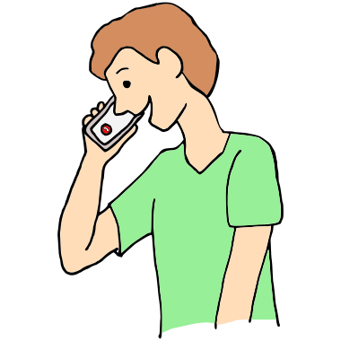
I may want to stay connected to my teacher too. We will ask my teacher how she prefers to stay connected with me. Some ways I can stay connected to my teacher could be:
- I can ask to talk to my teacher on the phone.
- I can send my teacher pictures of me doing my favorite activities.
- I can make a video to send to my teacher.
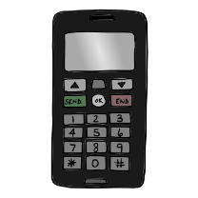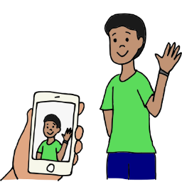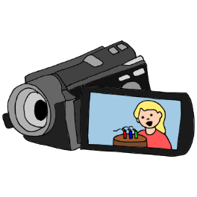

I will try to stay connected to my teacher while I am out of school.

